

Welcome, Juniors! We hope that you are all getting acclimated with your new lifestyle in an accelerated nursing program. In addition, we hope that you are taking time for yourselves. The Lake Mary Student Nurse Association would like to introduce our Junior Student Liaisons who will be representing the Cohort 15; **CONGRATULATIONS**

**Lindsey Krebsbach, CJ Santiago, Kelly Hernandez and Marcelo Alevato!**

The pulse:

march newsletter

editors: nikki BLAHut and Trea steele

The pulse

Can you find your funny bone? 

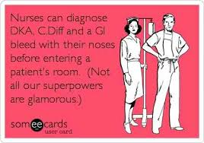

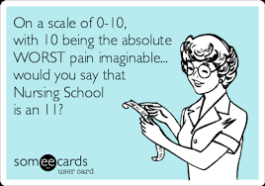

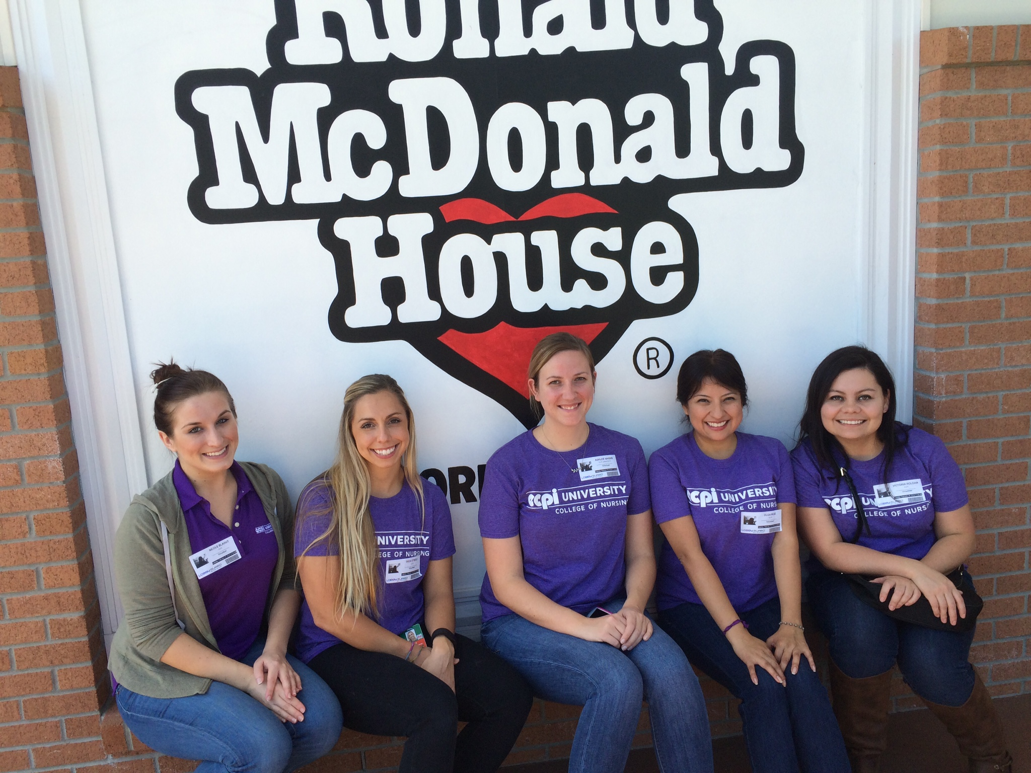

# lmsna: Lake mary student nurse assocation

Our Student Nurse Association at ECPI consists of 7 members dedicated to facilitating the needs of the student body. Professor Schofield is our faculty representative. Our President is Ashlee Harris and her right hand man is Vice-President, Anthony (Tony) Gustitus. The two of them work hard to coordinate our school events and keep us all on track. The senior Student Liaison, Daniel Thompson, welcomes any questions or concerns and is always available to lend a smile. Our math whiz is Olga Ruiz, the Treasurer, who keeps all of our fundraising efforts in check. Delaney Maclean, our Secretary, makes sure that our schedule is on point. Editors, Nikki Blahut and Trea Steele, will communicate all upcoming events and information with you all. On behalf of each one of us, WELCOME, JUNIORS and SENIORS, YOU ARE GETTING SO CLOSE TO THE FINISH LINE!

# ronald mcdonald house:

Our first volunteer experience this quarter was spent preparing a meal for the children and families at the Ronald McDonald House. Providing a meal for the Ronald McDonald house was a very heart-warming experience. Many of the families were so thankful and you could tell how appreciative they were. Due to the success that the students of ECPI University have had at the Ronald McDonald house, I'm sure we can expect to provide more meals in the future. If you are interested in participating, please be on the look-out for a bulletin providing further information!