**Free Installation**

**ECPI Students**

**Microsoft Office 2016**

Go to <https://mail.students.ecpi.edu>

Log in and click on the Install now button

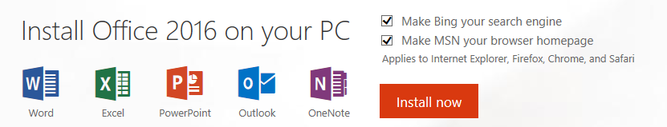

May be used on up to Five Devices (e.g. phone, tablet, laptop, desktop)