**MAKE SURE TO DONATE!**

**Collection Box Located in Library!**

**For:** Veterans who are Homeless!

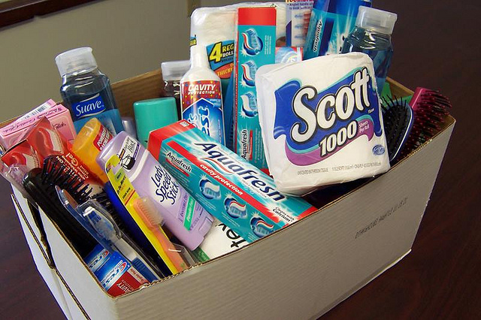

**DEADLINE:** June 16th!

THANK YOU!

