[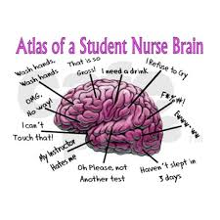](https://www.google.com/imgres?imgurl=https://s-media-cache-ak0.pinimg.com/736x/1d/1c/e1/1d1ce1946b300c7831c0075f1450b66d.jpg&imgrefurl=https://www.pinterest.com/gracie1090/nursing-school/&docid=E2x2E96h1UlvlM&tbnid=BHArCa04hNUHlM:&w=480&h=480&safe=off&bih=722&biw=1607&ved=0ahUKEwiH3onRoe_MAhXEph4KHbQeBrcQMwhYKDQwNA&iact=mrc&uact=8)

**IT’S OFFICAL!** The Lake Mary Student Nurse Association Board Members for Cohort 15 have been elected!

**CONGRATULATIONS!**

The pulse:

May newsletter

editors: nikki BLAHut and Trea steele

The pulse lmsna Welcomes ITs’ Newest members of cohort 15:



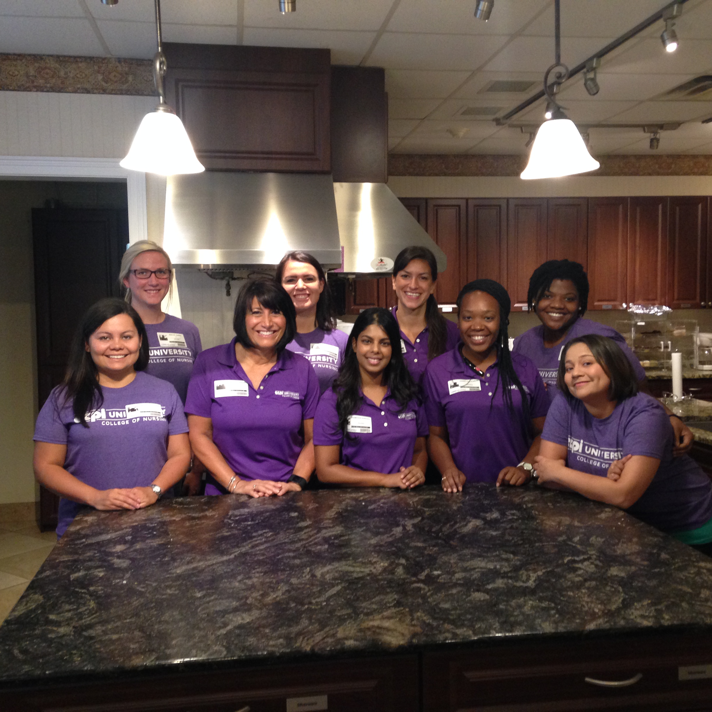

Ronald McDonald House: Mother’s Day 2016!

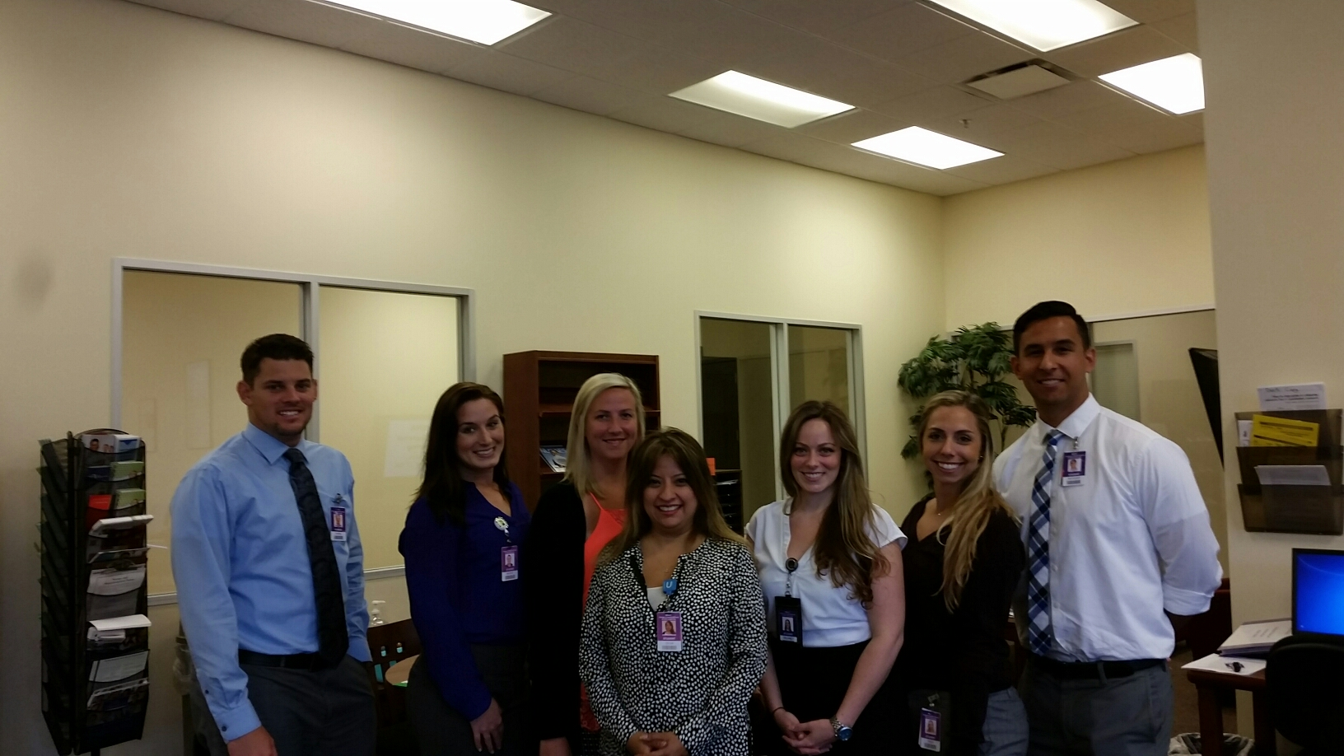

Seniors Meet with SACS!

**President:** Lindsay Krebsbach

**Vice President:** Clint Santiago

**Secretary:** Padma Sukhlall & Samantha Simpson

**Treasurer:** Alyssa Craig

**Editors:** Jessica Aquilino & Danielle Lockett! \

Once again, **CONGRATULATIONS!**

# Job opportunites:

Juniors, as you progress through your second quarter you become eligible for Nursing Assistant & Student Nurse Intern positions at both Florida Hospital & Orlando Health!

# seniors:

The end is near! **GOOD LUCK TO EVERYONE DURING THEIR PRACTICUM!**