 May | 2018
Monday | Tuesday | Wednesday | Thursday | Friday | Saturday | Sunday
 | 1 | 2 | 3  ONLY COHORT 19 | 4 | 5 | 6
Orlando Health
Job Fair - 12pm-1pm
7 | 8 | 9 | 10 | 11 | 12 | 13
AHSS/Fish Memorial Job Fair
12pm-1pm
14 | 15 | 16 | 17  ONLY COHORT 19 | 18 | 19 | 20
 |  | Central Florida Regional Hospital  L & L - 12pm-1pm | Florida Hospital  Job Fair -12pm-1pm
21 | 22 | 23 | 24 | 25 | 26 | 27
St. Vincent and Sacred Heart
L & L - 12pm-1pm
28 | 29 | 30 | 31
 |  | Nemours  Lunch and Learn  12pm-1pm | Orlando Health  ONLY COHORT 19  Practicum Luncheon 12pm-1pm
Events | 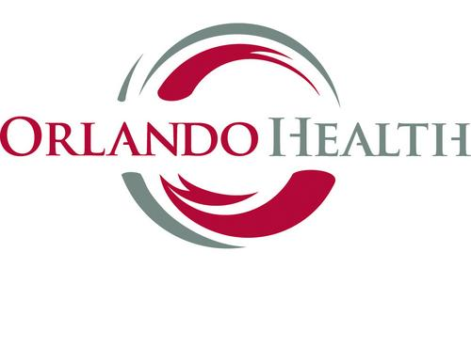 | 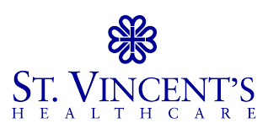 | 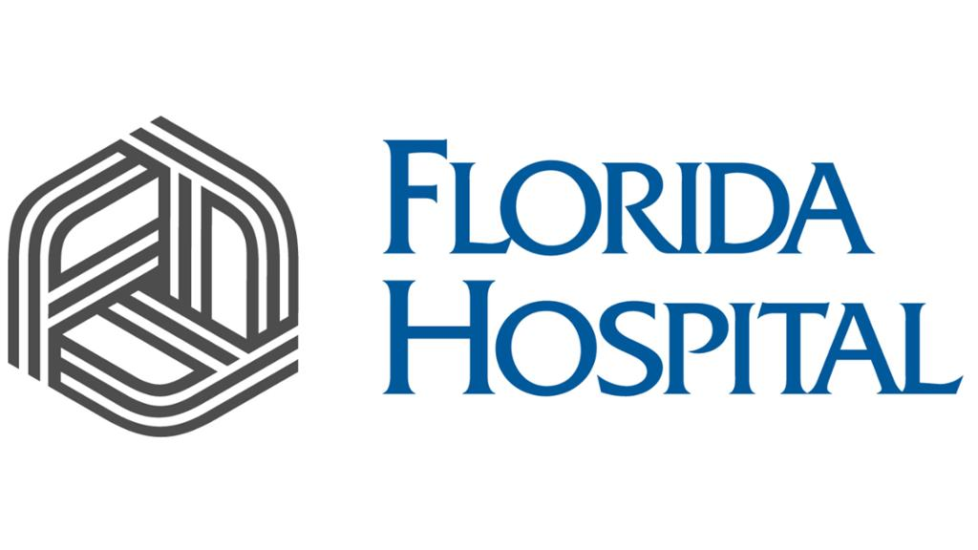 | 