LMSNA Newsletter
  - LAKE MARY STUDENT NURSES ASSoCIATION
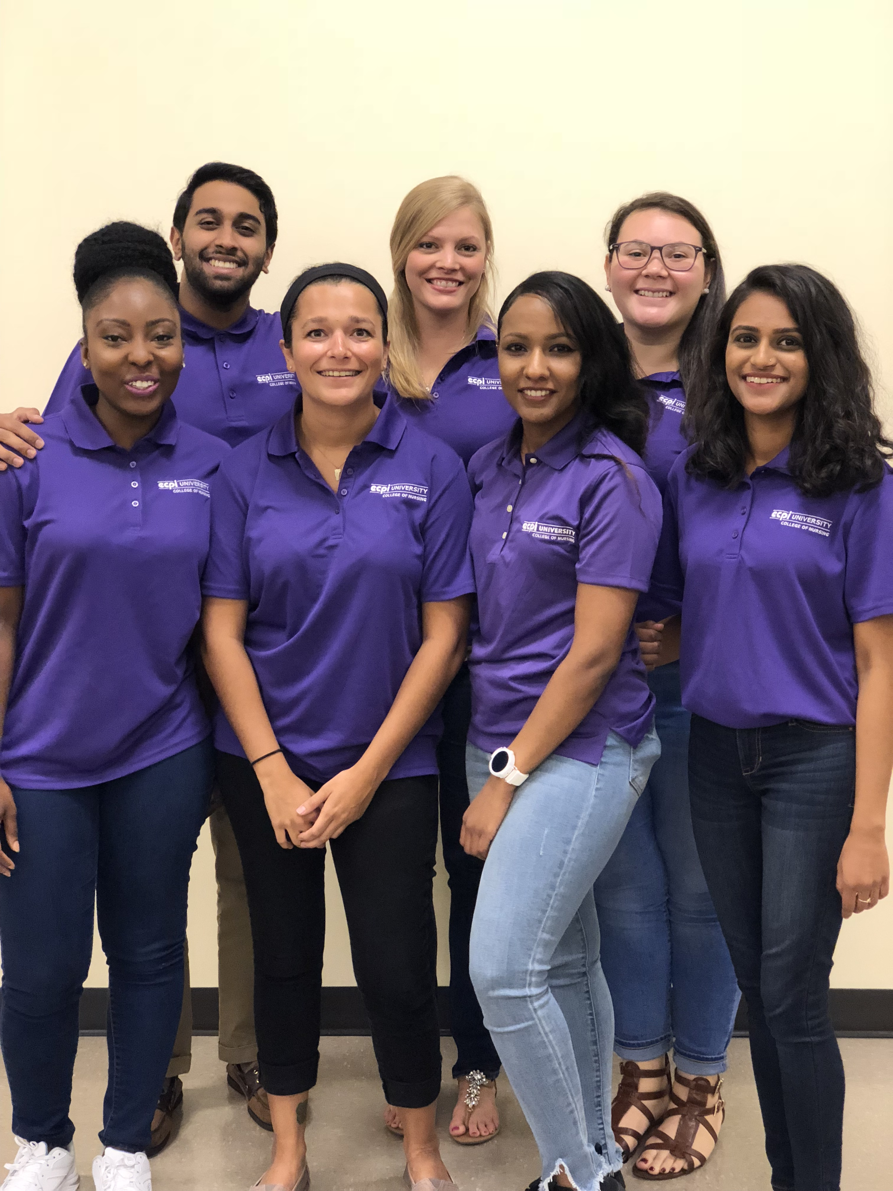
President – Eigan Smith
Vice President - George Koshy
Student Liaison - Judy Rodriguez

Treasurer - Marion Kufeji
Secretary - Jinal Patel
Editor - Emily Polo
Editor - Ashley Bryan

NEWS  Cohort 22 LMSNA Officers  Congratulations to the new Lake Mary Student Nurses Association officers from Cohort 22! We’re so glad to have you join and look forward to seeing what great things you will be doing for your class. | EVENTS  AHA Heart Walk  The American Heart Association will be hosting the Heart Walk on Nov. 3rd at 7:30am on the UCF campus. For information about signing up, contact Kara (Cohort 21 President). |  | MEETING  LMSNA General Meeting  All students are invited to attend the LMSNA General meeting on 9/24/18 @ 1:00pm. Come and provide feedback to your LMSNA officers and learn more about what’s going on at ECPI.
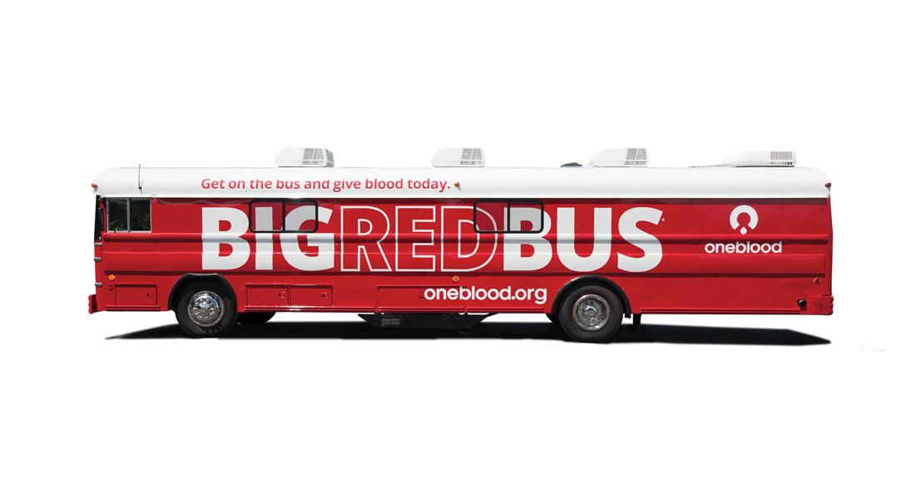 |  | OneBlood Drive/Presentation  The Big Red Bus will be on campus at ECPI University on September 26th from 10:30 am to 3:30 pm. Sign up today to give blood! There will also be a presentation at 12:30 from the OneBlood organization.

