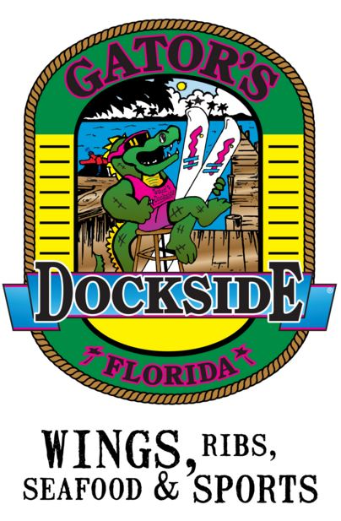Cohort 22 & 23

Mixer

**Gator’s Dockside**

5:30 pm Wednesday

January 30th

***Come meet your buddies and make new friends!!!***

**[4349 W Lake Mary Blvd,](https://www.bing.com/local?lid=YN183x3470461&id=YN183x3470461&q=Gator%27s+Dockside&name=Gator%27s+Dockside&cp=28.7548046112061%7e-81.3518676757812&ppois=28.7548046112061_-81.3518676757812_Gator%27s+Dockside&FORM=SNAPST)**

**[Lake Mary, FL 32746](https://www.bing.com/local?lid=YN183x3470461&id=YN183x3470461&q=Gator%27s+Dockside&name=Gator%27s+Dockside&cp=28.7548046112061%7e-81.3518676757812&ppois=28.7548046112061_-81.3518676757812_Gator%27s+Dockside&FORM=SNAPST)**