February 2019 Newsletter

# Upcoming Events

Wednesday February 27th – Q2 officer elections and speeches

Wednesday March 6th – One Blood ECPI Blood Drive 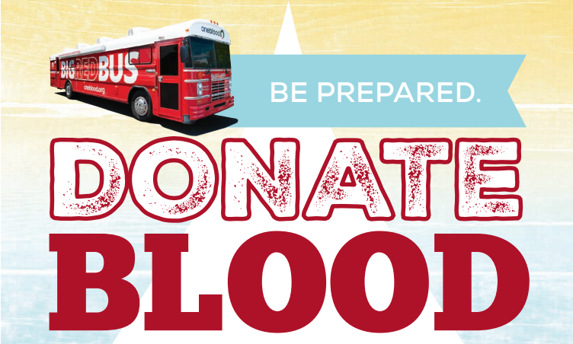

Opportunity to donate blood and win 2 Orlando Magic Tickets

Blood donations will take place Wednesday during class and there will be a sign-up sheet to determine what time you can donate

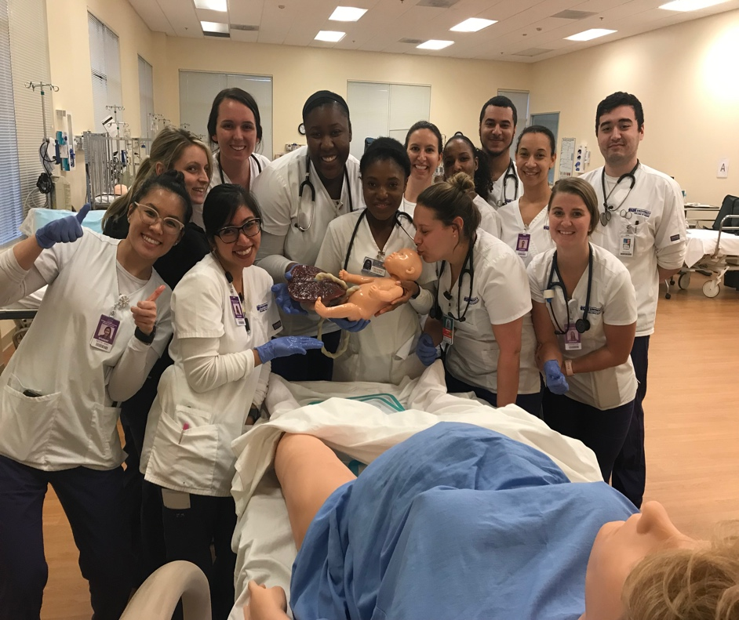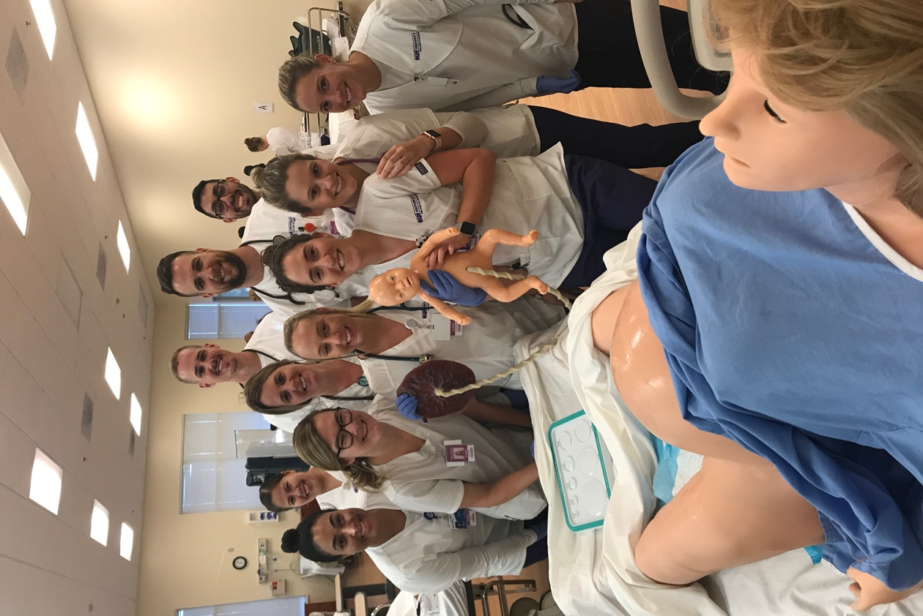Congratulations Victoria on teaching Q3 how to deliver multiple babies this January!