**Constitution Day**

**September 17th**

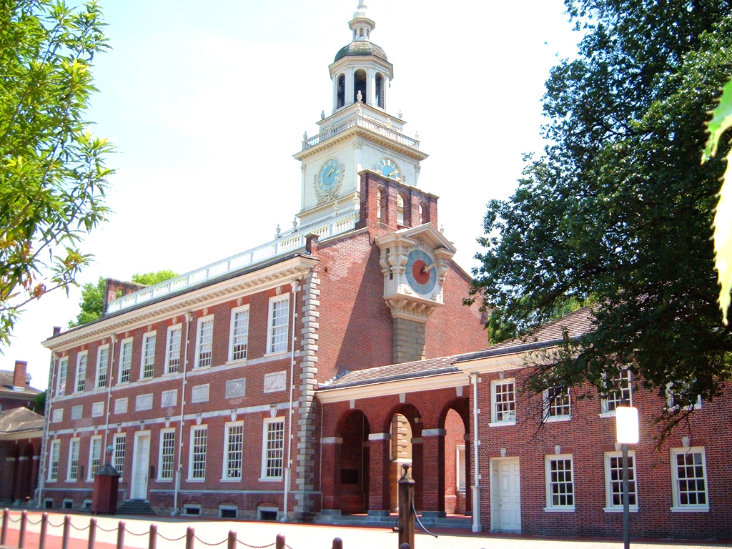

To recognize Constitution Day, Student Services will be presenting a PowerPoint presentation on the Constitution. This presentation will be playing on a loop in the Library all day Tuesday, September 17th. The presentation will feature unique and little known facts about the Constitution.