**ECPI UNIVERSITY-ORLANDO**

**ANNOUNCES THE FOURTH ANNUAL**

**HALLOWEEN COSTUME CONTEST**

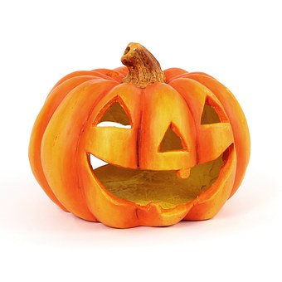

**2019 Halloween Costume Contest**

**WHEN: Thursday, October 31st, 2019 @ 1200**

**WHERE: Campus Library**

**WHO: Any ECPI University-Orlando student**

**WHY: Just for fun!**