Test-Taking Strategies NCLEX-Style

Workshop #2

Who: All Nursing Students

When: Monday, March 21st

Where: Lab 1

Time: 1:15 pm – 2:15 pm

Feel free to bring your lunch!

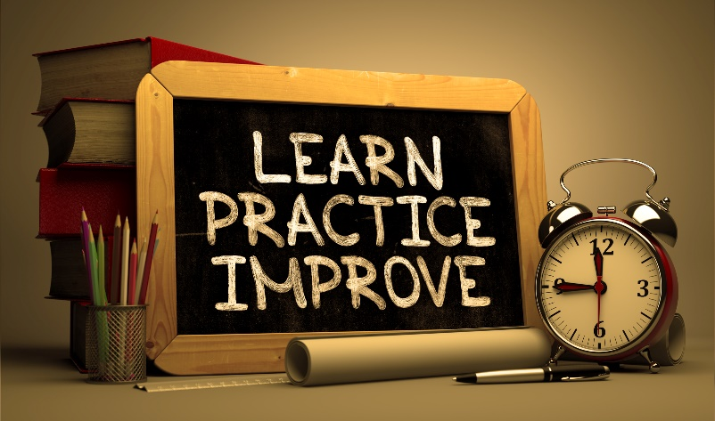

Presented by Deborah L. Stevenson, MSN, RN, CDP

[dstevenson@ecpi.edu](mailto:dstevenson@ecpi.edu)